Class Test 1

Regular Expressions and Validation in JavaScript
1. Student Registration Validation: Write a JavaScript program to validate a student
registration form containing a full name, email address, 10-digit mobile number, date
of birth in DD-MM-YYYY format, and password. The password must contain at least
one uppercase letter, one lowercase letter, one digit, and one special character, with
a minimum length of eight characters.
Program code :
<!DOCTYPE html>
<html lang="en">
<head>
<meta charset="UTF-8">
<title>Q1: Student Registration Validation</title>
<style>body { font-family: Arial; padding: 20px; }</style>
</head>
<body>
<h2>Q1: Student Registration Validation</h2>
<div id="output"></div>
<script>
const fullName = "K Venkata Siva Prasad";
const email = "prasadreddysankar5@gmiail.com";
const mobile = "9063247098";
const dob = "15-08-2003";
const password = "Prasad@9324";
const nameRegex = /^[A-Za-z\s]{2,50}$/;
const emailRegex = /^[^\s@]+@[^\s@]+\.[^\s@]{2,}$/;
const mobileRegex = /^\d{10}$/;
const dobRegex = /^(0[1-9]|[12][0-9]|3[01])-(0[1-9]|1[0-2])-\d{4}$/;
const passwordRegex = /^(?=.*[a-z])(?=.*[A-Z])(?=.*\d)(?=.*[\W_]).{8,}$/;
let html = `
<p>Full Name (${fullName}): <b>${nameRegex.test(fullName) ? "VALID" : "INVALID"}</b></p>
<p>Email (${email}): <b>${emailRegex.test(email) ? "VALID" : "INVALID"}</b></p>
<p>Mobile (${mobile}): <b>${mobileRegex.test(mobile) ? "VALID" : "INVALID"}</b></p>
<p>DOB (${dob}): <b>${dobRegex.test(dob) ? "VALID" : "INVALID"}</b></p>
<p>Password (${password}): <b>${passwordRegex.test(password) ? "VALID" : "INVALID"}</b></p>
`;
document.getElementById("output").innerHTML = html;
</script>
</body>
</html>
Output :
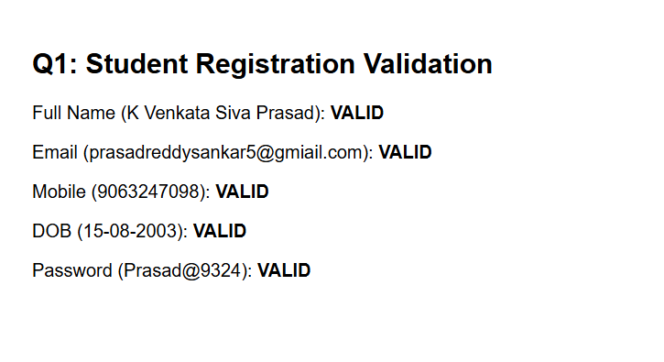
2. Password Strength Validation: Write a JavaScript program to validate a password
with the following rules: minimum 10 characters, at least two digits, one uppercase
letter, one lowercase letter, one special character, and no whitespace. Display an
appropriate error message for each failed condition.
Program code :
<!DOCTYPE html>
<html lang="en">
<head>
<meta charset="UTF-8">
<title>Q2: Password Strength Validation</title>
<style>body { font-family: Arial; padding: 20px; }</style>
</head>
<body>
<h2>Q2: Password Strength Validation</h2>
<div id="output"></div>
<script>
const password = "Prasad@9324";
let errors = [];
if (password.length < 10) errors.push("Minimum 10 characters required.");
if (!/[A-Z]/.test(password)) errors.push("At least one uppercase letter required.");
if (!/[a-z]/.test(password)) errors.push("At least one lowercase letter required.");
if ((password.match(/\d/g) || []).length < 2) errors.push("At least two digits required.");
if (!/[\W_]/.test(password)) errors.push("At least one special character required.");
if (/\s/.test(password)) errors.push("No whitespace allowed.");
let html = `<p>Testing Password: <b>"${password}"</b></p>`;
if (errors.length === 0) {
html += `<p style="color: green;"><b>Password is strong and valid!</b></p>`;
} else {
html += `<ul>` + errors.map(e => `<li style="color: red;">${e}</li>`).join('') + `</ul>`;
}
document.getElementById("output").innerHTML = html;
</script>
</body>
</html>
Output:
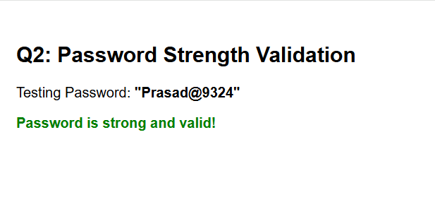3. Email Address Validation: Write a JavaScript program to validate email addresses
according to these rules: the address must contain exactly one @, a non-empty
username, a domain name, and a valid-looking extension of at least two letters.
Reject spaces and consecutive dots.
Program code:
<!DOCTYPE html>
<html lang="en">
<head>
<meta charset="UTF-8">
<title>Q3: Email Address Validation</title>
<style>body { font-family: Arial; padding: 20px; }</style>
</head>
<body>
<h2>Q3: Email Address Validation</h2>
<div id="output"></div>

<script>
function validateEmail(email) {
if (email.includes(' ') || email.includes('..')) return "Invalid (contains spaces or consecutive dots)";
const parts = email.split('@');
if (parts.length !== 2) return "Invalid (must contain exactly one @)";
if (parts[0].length === 0) return "Invalid (empty username)";
const emailRegex = /^[a-zA-Z0-9._%+-]+@[a-zA-Z0-9.-]+\.[a-zA-Z]{2,}$/;
if (!emailRegex.test(email)) return "Invalid format or extension too short";
return "VALID";
}
const testEmail = "venkatasivaprasadk@gmail.com";
document.getElementById("output").innerHTML = `
<p>Email: <b>"${testEmail}"</b></p>
<p>Result: <b>${validateEmail(testEmail)}</b></p>
`;
</script>
</body>
</html>
output :
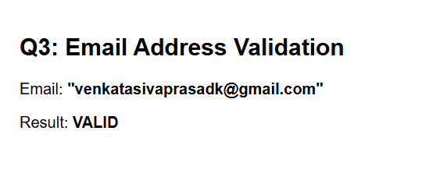
4. Username Validation: Write a JavaScript program to validate a username that
must start with a letter, contain only letters, digits, and underscores, have a length of
6–15 characters, and must not end with an underscore or contain consecutive
underscores.
Program code:
<!DOCTYPE html>
<html lang="en">
<head>
<meta charset="UTF-8">
<title>Q4: Username Validation</title>
<style>body { font-family: Arial; padding: 20px; }</style>
</head>
<body>
<h2>Q4: Username Validation</h2>
<div id="output"></div>
<script>
function validateUsername(uname) {
if (uname.length < 6 || uname.length > 15) return "Invalid (Length must be 6-15 characters)";
if (!/^[a-zA-Z]/.test(uname)) return "Invalid (Must start with a letter)";
if (/[_]$/.test(uname)) return "Invalid (Cannot end with an underscore)";
if (/__/.test(uname)) return "Invalid (Cannot contain consecutive underscores)";
if (!/^[a-zA-Z0-9_]+$/.test(uname)) return "Invalid (Contains unsupported characters)";
return "VALID";
}
const testUsername = "prasad_siva";
document.getElementById("output").innerHTML = `
<p>Username: <b>"${testUsername}"</b></p>
<p>Result: <b>${validateUsername(testUsername)}</b></p>
`;
</script>
</body>
</html>
Output:
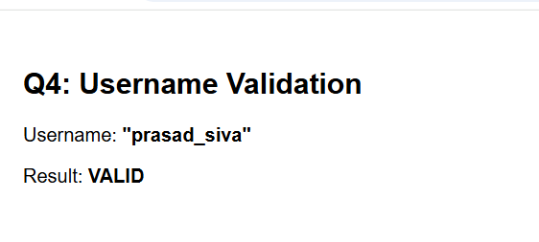
5. Extract and Analyse Data: Write a JavaScript program to extract all mobile
numbers, email addresses, and dates from a paragraph using regular expressions.
Display each category separately.
Program code:
<!DOCTYPE html>
<html lang="en">
<head>
<meta charset="UTF-8">
<title>Q5: Extract and Analyze Data</title>
<style>body { font-family: Arial; padding: 20px; }</style>
</head>
<body>
<h2>Q5: Extract and Analyze Data</h2>
<div id="output"></div>
<script>
const paragraph = "My name is K Venkata Siva Prasad. Reach me at prasadreddysankar5@gmiail.com or call 9063247098. Registered on 15-08-2026.
const mobileRegex = /\b\d{10}\b/g;
const emailRegex = /\b[A-Za-z0-9._%+-]+@[A-Za-z0-9.-]+\.[A-Za-z]{2,}\b/g;
const dateRegex = /\b(0[1-9]|[12][0-9]|3[01])-(0[1-9]|1[0-2])-\d{4}\b/g;
const mobiles = paragraph.match(mobileRegex) || [];
const emails = paragraph.match(emailRegex) || [];
const dates = paragraph.match(dateRegex) || [];
document.getElementById("output").innerHTML = `
<p><b>Paragraph:</b> ${paragraph}</p>
<hr>
<p><b>Extracted Mobile Numbers:</b> ${JSON.stringify(mobiles)}</p>
<p><b>Extracted Email Addresses:</b> ${JSON.stringify(emails)}</p>
<p><b>Extracted Dates:</b> ${JSON.stringify(dates)}</p>
`;
</script>
</body>
</html>
Output: 